FORM 317

(See rule 24 )

Order of cancellation of assessment order under sub-section (11) of section 23 of the Maharashtra Value Added Tax Act, 2002

To
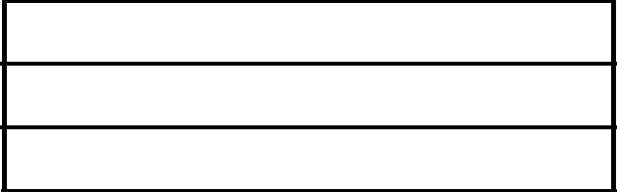
M/s

No.: Dated:

(1) Name of the Dealer
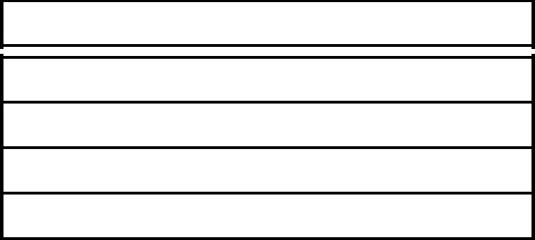
- Address of the place of Business

(3) R.C. No. /TIN M.V.A.T. Act, 2002
(4) R.C. No. /TIN under CST Act, 1956.

With reference to your application in Form -316 dated _________ the assessment order for the period from _______________ to ____________________

is hereby cancelled.

Date
 |  |  | Signature and Stamp of Assessing
Place |  |  | Authority

FORM 317

(See rule ____)

Original

Order of cancellation of assessment order under sub-section (11) of section 23 of the Maharashtra Value Added Tax Act, 2002

To
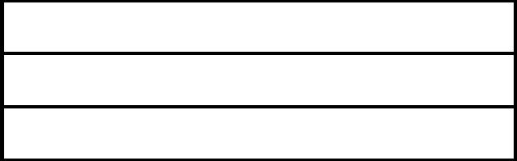

No.: Dated:

(1) Name of the Dealer
- Address of the place of Business

(3) TIN M.V.A.T. Act, 2002
(4) TIN under CST Act, 1956.

With reference to your application in Form -316 dated _________ the assessment order for the period from _______________ to ____________________

is hereby cancelled.

Date
 |  | Signature and Stamp of Assessing
Place |  | Authority

